**IBM SMARTINTERNZ**

**LITERATURE SURVEY ON THE SELECTED PROJECT & INFORMATION GATHERING**

**Survey took by:** Harsha J S(917719C032), Vasanth Kumar M (917719C113)**.**

**Literature Survey:**

**1.Topic:** Machine Learning Based Real-Time Vehicle Data Analysis for Safe Driving Modeling

**Authors:** Pamul Yadav, Sangsu Jung, Dhananjay Singh

**Abstract:**

This paper identifies a necessity to evaluate the Meta features of vehicles which could be helpful in improving the vehicle driver’s skill to prevent accidents and also evaluate the change in the quality of cars over passing time. This paper does an analysis of the vehicle data using supervised learning based linear regression model that is used as an estimator for Driver’s Safety Metrics and Economic Driving Metrics. The data collected was obtained from fifteen different drivers over a span of one month which accumulated over 15000 data points. And the metrics that we have devised have potential application in automotive technology analysis for developing an advanced intelligent vehicles. Also, we have presented a system for performing the real-time experiment based on the OnBoard-Diagnosis version II (OBD-II) scanner data. Finally, we have analyzed and presented the parameter accuracy over 80% for the driver’s safety solution in real-world scenario.

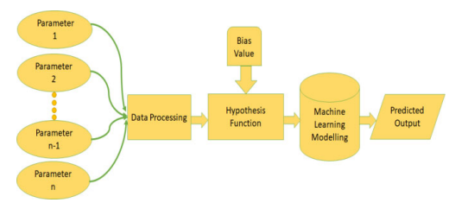**Architecture:**

**Inference:**

In this paper the have obtained some newer insights about the car data analysis such as economic driving index (ECN_DRVG_INDX) and safety driving index (SFTY_DRVG_INDX.) The results have proven to be approximately 80% fitting the given features and are very helpful to be used in different use cases such as a parameter in finding the driver’s driving performance in a driving school, as a good estimate for finding an optimal price for a used car that can be based on several factors which we have analyzed in this paper etc..

**2.Topic:** Performance of Motor Vehicle based on Driving and Vehicle Data using Machine Learning

**Authors:** Punith Kumar, Nagaraje Gowda

**Inference:**

This paper presents a with the increasing population demographics and the dependency of man on motor vehicles as the primary source of transportation, the number of motor vehicles being registered for commercial as well as non-commercial activities on a daily basis is massive and yet continues to increase at an alarming rate. This has a direct and an unambiguous effect on the amount of fossil fuels being utilized globally and its subsequent environmental effects, which is of great concern in the present situation. Several attempts from various research sectors are ongoing in order to overcome this global issue and promising results are expected. This project is one such attempt at identifying the performance of small passenger cars in terms of fuel efficiency and map them with factors affecting it using machine learning techniques. The commencing activity while carrying out any such research activity will be the identification of the problem and all its possible sources. In this case, two potential sources can be identified and they are; the vehicle characteristics and the driver/driving behaviour. The relevant data for this analysis was taken from the public source, Kaggle which is the data collected from the OBD of the car and models are built using techniques like Multiple Linear Regression, XGBoost, Support Vector Machine and Artificial Neural Network and their performance is compared to discover the firstrate technique in predicting the fuel efficiency and to propose the optimum driving behaviour in terms of throttle position to achieve better fuel efficiency. The results reveal that XGBoost model outperforms all other models developed in predicting the fuel efficiency for the different split ratios evaluated and comparing the throttle position with the predicted fuel efficiency explains that to achieve better fuel efficiency the throttle position must be around 70 to 80 on a scale of 100, referred to as full throttle position. The knowledge discovered from the research could be used by car manufacturers to design cars in future to mitigate the fuel consumption.

**Methodology:**

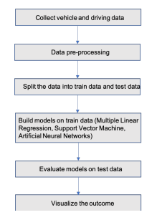  
**Inference:**

In this paper there is more scope in future for research and analysis of fuel efficiency by including other factors like the road condition and real-time traffic with the help of google maps, this would help in analysing much deeper. The knowledge discovered from the research and future work can be used by the car manufacturing companies to improve the fuel economy by considering the characteristics that substantially influence the fuel efficiency.